Windows 11 Print Dialog
In Windows 11 22H2, Microsoft replaced the legacy print dialog for all classic (win32) applications, e.g., Notepad, WordPad, Notepad++, etc., with a new modern print dialog.

In this modern print dialog, the preview pane always shows “No preview available,” regardless of the previewed file type, and the title bar reads “Printing from Win32 application” instead of the program’s name — e.g., Notepad++.

In addition, the modern print dialog prevents EmpowerWin from setting the default number of copies.
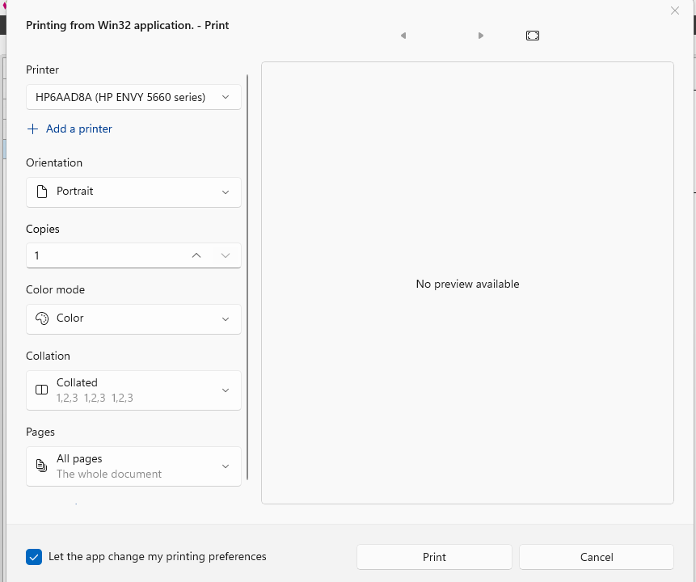

To put back the legacy print dialog:

Start the Registry Editor (regedit.exe) and go to the following branch:

Computer\HKEY_CURRENT_USER\Software\Microsoft\Print\UnifiedPrintDialog

Create a new REG_DWORD value named PreferLegacyPrintDialog

Set PreferLegacyPrintDialog to 1.

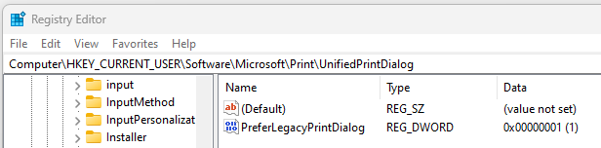

Exit the Registry Editor.
Windows 11 then uses the legacy print dialog which allows EmpowerWin to set the number of copies.
